KPR Institute of Engineering and Technology
Department of Artificial Intelligence and Data Science

U21ADP05 - Exploratory Data Analysis and Visualization

ASSIGNMENT II

A Real-World Case Study of Breast Cancer Diagnosis Data

Student Name : SRIJANE JN
Roll Number : 24AD117
Class : III AD B
Semester : V Semester
Batch : 2024 - 2028
Date of Submission : 19/10/2026

Abstract
This case study applies exploratory data analysis, statistical summaries, visualization and a Multilayer Perceptron (MLP) classifier to the Wisconsin Diagnostic Breast Cancer dataset. The data contains 569 records and 30 numerical predictor features with a binary diagnosis label. The workflow checks data quality, explores distributions and relationships, creates a stratified train/validation/test split, standardizes features without data leakage, compares four MLP configurations and evaluates the selected model on a held-out test set. In this generated run, test accuracy is 95.35% and ROC-AUC is 0.9936. This is an educational project only and is not a clinical diagnostic tool.

1. Introduction and Objectives
Exploratory Data Analysis (EDA) helps understand data quality, feature distributions and relationships before predictive modeling. This project uses a real-world medical measurement dataset to demonstrate a complete EDA, visualization and Deep Learning workflow.
- Inspect structure, missing values, duplicates and class balance.
- Create and interpret at least five EDA visualizations.
- Perform statistical and distribution analysis, including univariate and multivariate exploration.
- Split the dataset into train, validation and test sets and avoid preprocessing leakage.
- Train an MLP model, compare basic hyperparameters and evaluate results.
- Summarize findings, limitations, references and future scope.

2. Dataset Description
The Wisconsin Diagnostic Breast Cancer dataset is distributed through scikit-learn and originates from the UCI Machine Learning Repository. The project CSV contains 569 records, 30 numerical predictor features and a diagnosis label (malignant or benign). Feature families include mean, standard-error and worst measurements for radius, texture, perimeter, area, smoothness, compactness, concavity and symmetry.
Property | Description
Records | 569
Predictor features | 30 numerical features
Target | Diagnosis: malignant / benign
Source | Wisconsin Diagnostic Breast Cancer dataset; scikit-learn / UCI

3. EDA and Preprocessing
The supplied table has 0 missing cells and 0 duplicate rows. These are explicitly checked. Median imputation is included as a robust preprocessing step. Potential outliers are reviewed visually rather than automatically removed. A stratified split creates 398 training (69.9%), 85 validation (14.9%) and 86 test (15.1%) records. The imputer and scaler are fitted on training data only.

4. Data Visualizations
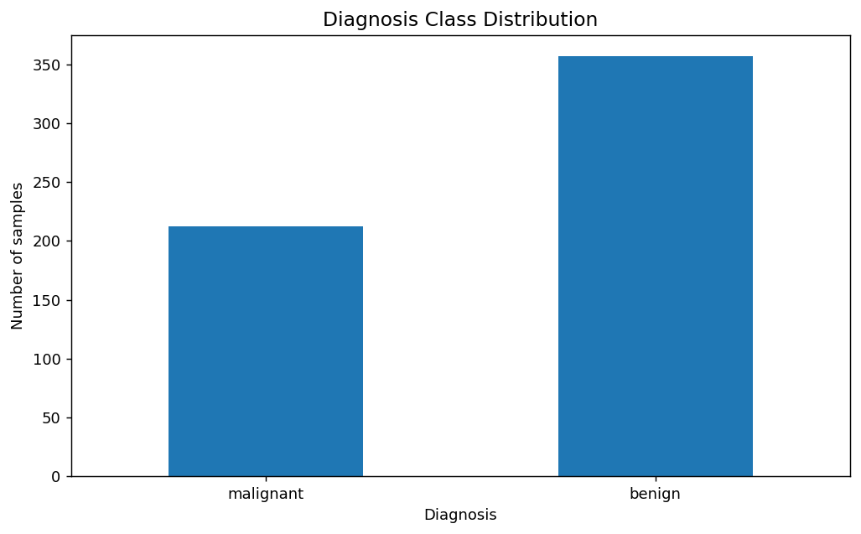
Figure 1. Diagnosis class distribution
Purpose: check target balance. Insight: the class counts show that both labels are represented, but the distribution is not perfectly even; stratified splitting is therefore appropriate.
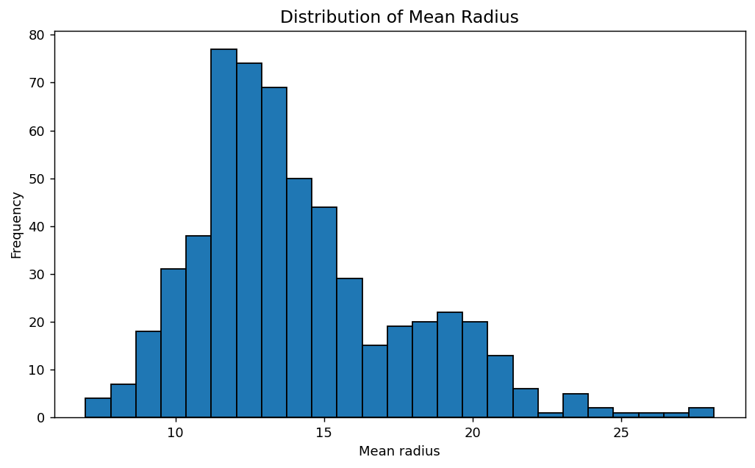
Figure 2. Distribution of mean radius
Purpose: inspect a single continuous feature. Insight: the histogram shows its spread and shape, which can inform later transformation and model choices.
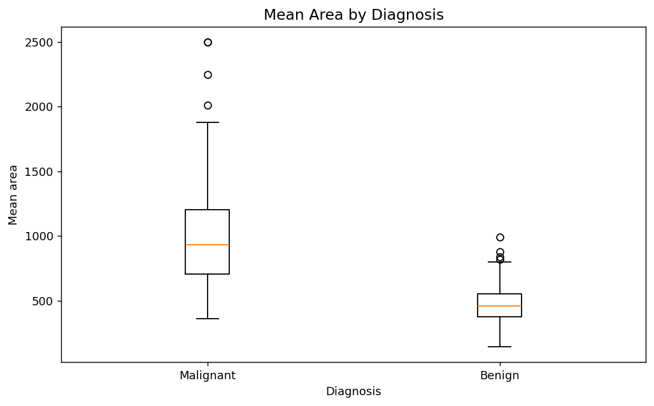
Figure 3. Mean area by diagnosis
Purpose: compare distributions and identify potential outliers. Insight: the groups show differences in central tendency and spread; outliers are retained pending domain justification.
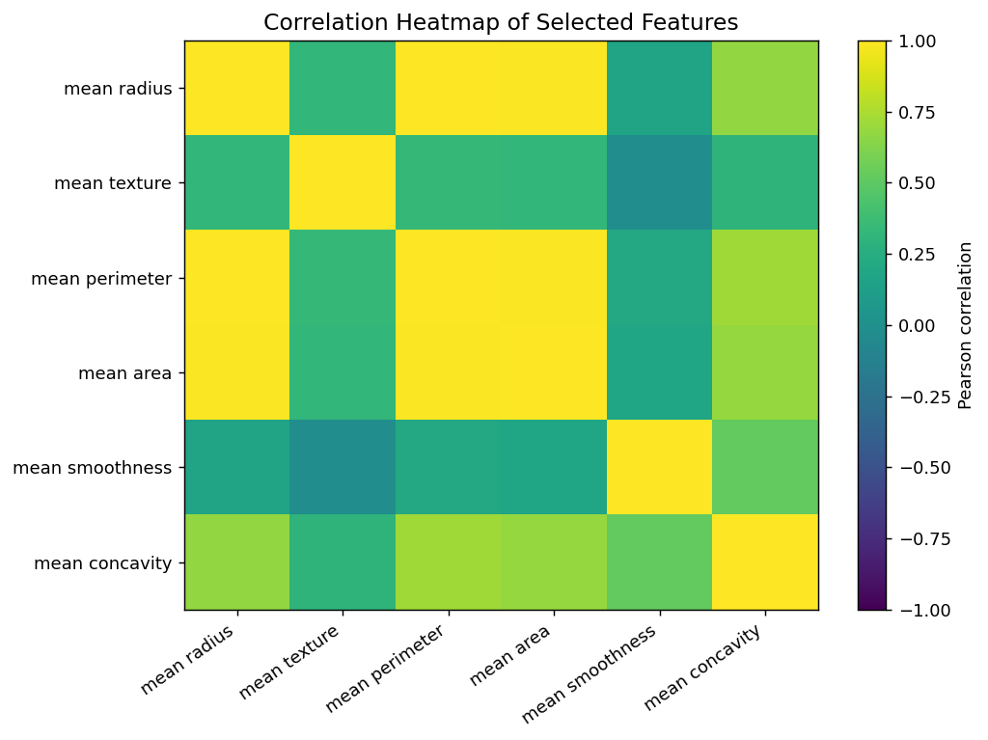
Figure 4. Correlation heatmap
Purpose: inspect relationships among selected measurements. Insight: size-related features show strong association, suggesting overlapping information in some predictors.
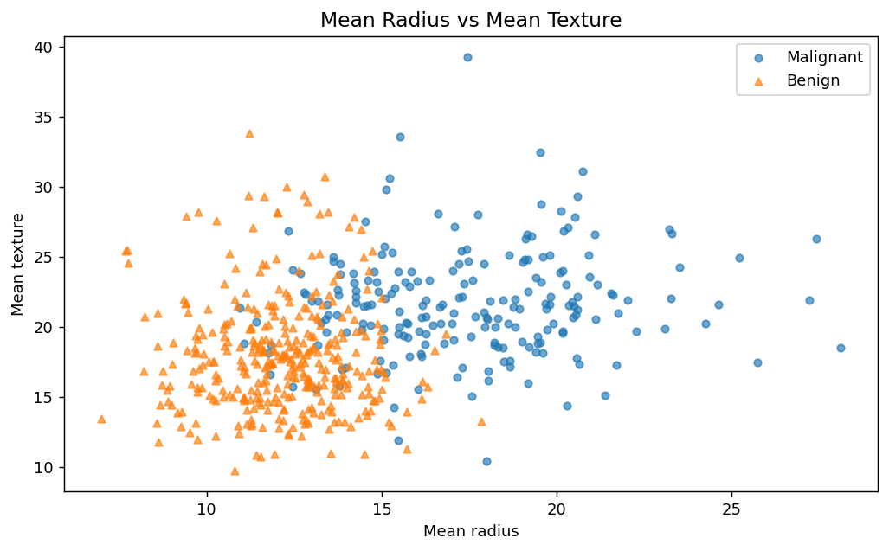
Figure 5. Mean radius vs mean texture
Purpose: inspect a bivariate relationship and class overlap. Insight: the scatter shows group patterns, but overlap indicates that these two features alone do not perfectly separate diagnoses.
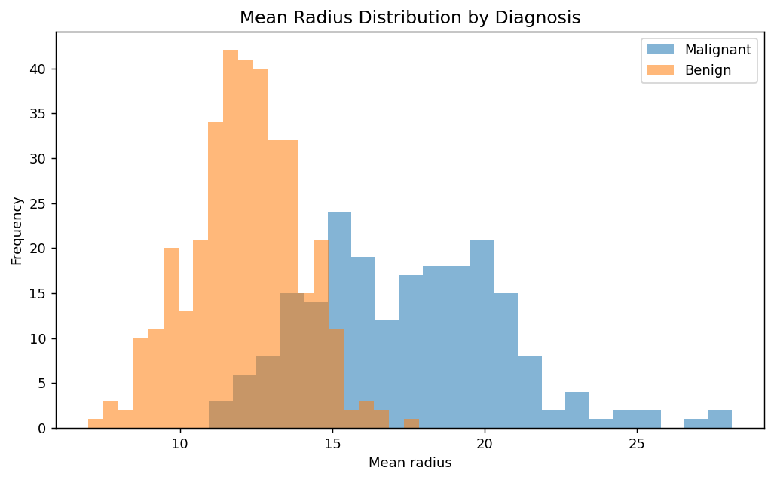
Figure 6. Mean radius distribution by diagnosis
Purpose: compare one feature across target classes. Insight: the class-conditional distributions differ, while any overlap reinforces the need for multiple features.

5. Deep Learning Model
A Multilayer Perceptron (MLP) classifier is used for binary classification. The selected hidden-layer layout is (64, 32), with ReLU activation, Adam optimization and alpha = 0.0001. Four configurations were compared using validation accuracy.
Hidden layers | Alpha | Validation accuracy
(32,) | 0.0001 | 0.9765
(64, 32) | 0.0001 | 0.9882
(32,) | 0.01 | 0.9765
(64, 32) | 0.01 | 0.9882

6. Model Evaluation and Interpretation
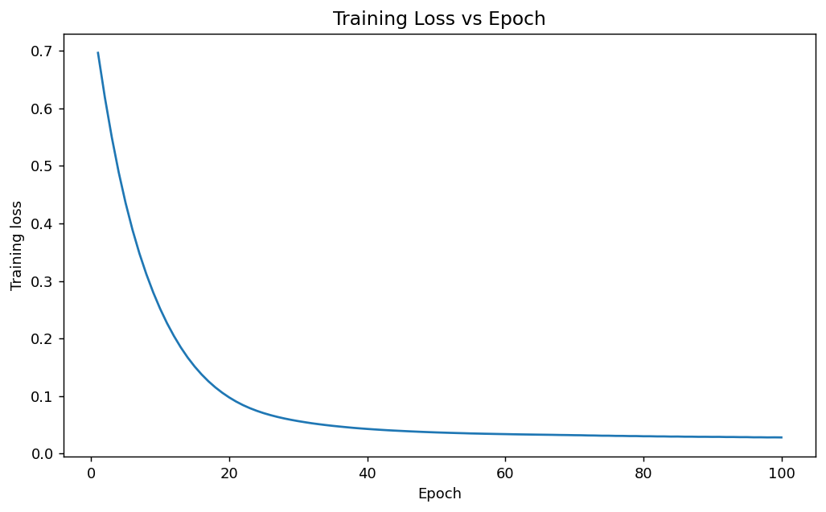
Figure 7. Training loss vs epoch
The loss curve tracks optimization progress. A downward trend generally indicates learning, while stochastic optimization may cause fluctuations.
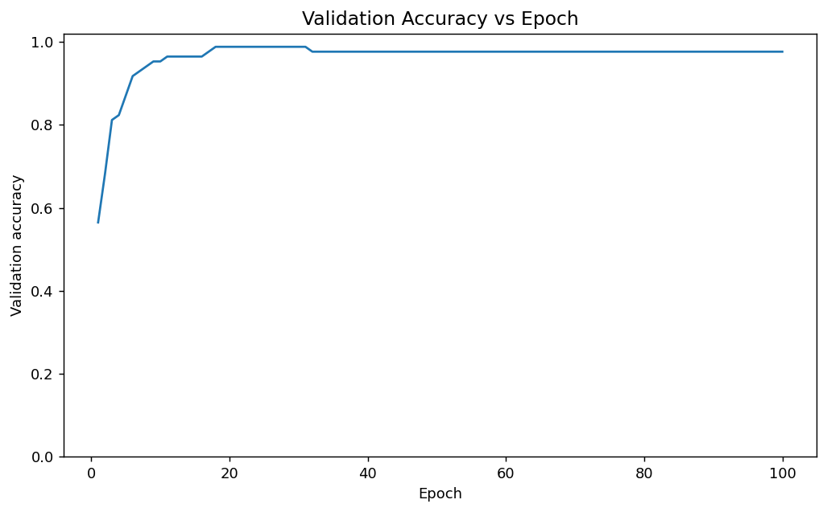
Figure 8. Validation accuracy vs epoch
The validation-accuracy curve tracks predictions on held-out validation records across epochs. It helps reveal instability or a plateau and should be interpreted with loss and final test metrics.
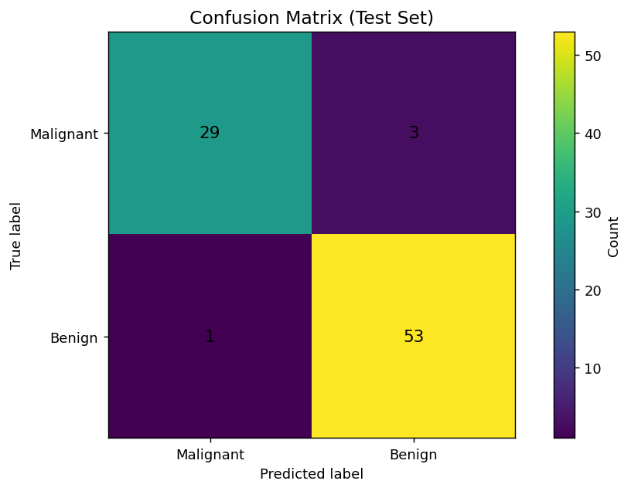
Figure 9. Confusion matrix on the test set
Rows are true labels and columns are predicted labels, ordered malignant then benign. The matrix is [[29, 3], [1, 53]], making correct and incorrect classifications visible.
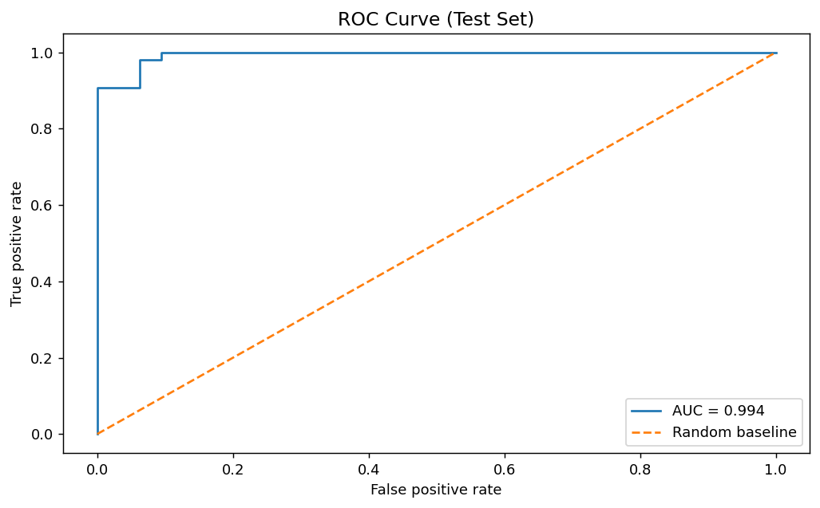
Figure 10. ROC curve on the test set
The ROC curve compares true-positive rate and false-positive rate across thresholds. AUC summarizes ranking performance but does not establish clinical safety or guarantee generalization.
Metric | Value
Accuracy | 0.9535
Precision (benign) | 0.9464
Recall (benign) | 0.9815
F1-score (benign) | 0.9636
ROC-AUC (benign score) | 0.9936

On the held-out test set, accuracy is 95.35%, benign-class precision is 94.64%, benign-class recall is 98.15%, benign-class F1-score is 96.36%, and ROC-AUC is 0.9936. Metrics are split-specific and do not establish clinical usefulness.

7. Conclusion, Limitations and Future Scope
7.1 Conclusion
This case study demonstrates the application of Exploratory Data Analysis (EDA), data visualization, and a Multi-Layer Perceptron (MLP) classifier for breast cancer classification. Histograms, boxplots, correlation heatmaps, and scatterplots help understand feature distributions, relationships, and class overlap. The selected MLP model achieved the reported test performance, demonstrating the potential of machine learning for classification tasks.
7.2 Limitations
- Small dataset: The study uses a limited dataset, which may not represent all breast cancer cases.
- Correlated predictors: Some features are highly correlated, which may affect model interpretation.
- Single data split: Evaluation using one train-validation-test split may produce results that vary with different splits.
- No external validation: The model has not been tested on an independent external dataset.
7.3 Future Scope
- Cross-validation: Use repeated stratified cross-validation to obtain more reliable performance estimates.
- Model calibration: Evaluate whether predicted probabilities accurately reflect the likelihood of each class.
- External validation: Test the model using independent datasets to assess its generalizability.
- Interpretability: Apply feature importance and explainability techniques to understand model predictions.
- Model comparison: Compare the MLP with other classifiers, such as Logistic Regression, Support Vector Machine, Random Forest, and Gradient Boosting.

8. Literature Review
Wolberg, Street and Mangasarian studied machine-learning techniques for breast cancer diagnosis from fine-needle aspirates. The UCI repository documents the dataset, scikit-learn documents the dataset loader and MLPClassifier, and Matplotlib provides the plotting environment. These sources support the dataset and tools but do not validate this particular model for clinical use.

9. References (APA style)
- Wolberg, W. H., Street, W. N., & Mangasarian, O. L. (1995). Machine learning techniques to diagnose breast cancer from fine-needle aspirates. Cancer Letters, 77(2–3), 163–171.
- UCI Machine Learning Repository. (n.d.). Breast Cancer Wisconsin (Diagnostic) Data Set. https://archive.ics.uci.edu/dataset/17/breast+cancer+wisconsin+diagnostic
- scikit-learn developers. (n.d.). Breast cancer Wisconsin (diagnostic) dataset. https://scikit-learn.org/stable/modules/generated/sklearn.datasets.load_breast_cancer.html
- scikit-learn developers. (n.d.). MLPClassifier. https://scikit-learn.org/stable/modules/generated/sklearn.neural_network.MLPClassifier.html
- Hunter, J. D. (2007). Matplotlib: A 2D graphics environment. Computing in Science & Engineering, 9(3), 90–95.

APPENDIX – SOURCE CODE
1. Import libraries and load the dataset
The dataset is distributed by scikit-learn and originates from the Wisconsin Diagnostic Breast Cancer dataset.

import numpy as np
import pandas as pd
import matplotlib.pyplot as plt
from sklearn.datasets import load_breast_cancer
from sklearn.model_selection import train_test_split
from sklearn.impute import SimpleImputer
from sklearn.preprocessing import StandardScaler
from sklearn.neural_network import MLPClassifier
from sklearn.metrics import (accuracy_score, precision_score, recall_score, f1_score,confusion_matrix, classification_report, roc_curve, roc_auc_score)
RANDOM_STATE = 42
data = load_breast_cancer(as_frame=True)
df = data.frame.copy()
df["diagnosis"] = df["target"].map({0: "malignant", 1: "benign"})
df.drop(columns=["target"], inplace=True)
print("Dataset shape:", df.shape)
print("Predictor feature count:", len(data.feature_names))
display(df.head())

2. Dataset understanding and data-quality checks
Check data types, missing cells, duplicate rows, class balance and descriptive statistics before modeling.

print("Data types:")
display(df.dtypes.value_counts().rename("column_count").to_frame())
print("Missing values per column (non-zero only):")
display(df.isna().sum()[df.isna().sum() > 0])
print("Total missing cells:", int(df.isna().sum().sum()))
print("Duplicate rows:", int(df.duplicated().sum()))
print("Diagnosis counts:")
display(df["diagnosis"].value_counts().to_frame("count"))
print("Descriptive statistics:")
display(df.describe().T)

3. Exploratory data analysis and visualizations
Each chart includes a purpose and a short interpretation.

# Visualization 1: diagnosis class distribution
df["diagnosis"].value_counts().reindex(["malignant", "benign"]).plot(kind="bar")
plt.title("Diagnosis Class Distribution")
plt.xlabel("Diagnosis"); plt.ylabel("Number of samples"); plt.xticks(rotation=0)
plt.tight_layout(); plt.show()

# Visualization 2: distribution of mean radius
plt.hist(df["mean radius"], bins=25, edgecolor="black")
plt.title("Distribution of Mean Radius")
plt.xlabel("Mean radius"); plt.ylabel("Frequency")
plt.tight_layout(); plt.show()

# Visualization 3: outlier/spread review by diagnosis
groups = [df.loc[df["diagnosis"] == label, "mean area"] for label in ["malignant", "benign"]]
plt.boxplot(groups, labels=["Malignant", "Benign"], showfliers=True)
plt.title("Mean Area by Diagnosis")
plt.xlabel("Diagnosis"); plt.ylabel("Mean area")
plt.tight_layout(); plt.show()

# Visualization 4: correlation heatmap for selected numeric features
selected = ["mean radius", "mean texture", "mean perimeter", "mean area", "mean smoothness", "mean concavity"]
corr = df[selected].corr()
plt.figure(figsize=(8, 6))
plt.imshow(corr, vmin=-1, vmax=1, aspect="auto")
plt.colorbar(label="Pearson correlation")
plt.xticks(range(len(selected)), selected, rotation=35, ha="right")
plt.yticks(range(len(selected)), selected)
plt.title("Correlation Heatmap of Selected Features")
plt.tight_layout(); plt.show()

# Visualization 5: relationship between mean radius and mean texture
for label, marker in [("malignant", "o"), ("benign", "^")]:
subset = df[df["diagnosis"] == label]
plt.scatter(subset["mean radius"], subset["mean texture"], label=label.title(), marker=marker, alpha=0.65, s=22)
plt.title("Mean Radius vs Mean Texture")
plt.xlabel("Mean radius"); plt.ylabel("Mean texture"); plt.legend()
plt.tight_layout(); plt.show()

# Visualization 6: compare mean-radius distributions by diagnosis
for label in ["malignant", "benign"]:
plt.hist(df.loc[df["diagnosis"] == label, "mean radius"], bins=22, alpha=0.55, label=label.title())
plt.title("Mean Radius Distribution by Diagnosis")
plt.xlabel("Mean radius"); plt.ylabel("Frequency"); plt.legend()
plt.tight_layout(); plt.show()

4. Train / validation / test split and preprocessing
Use a stratified 70/15/15 split. Fit imputation and standardization on training data only.

feature_cols = list(data.feature_names)
X = df[feature_cols].copy()
y = data.target.copy() # 0 = malignant, 1 = benign
X_train, X_temp, y_train, y_temp = train_test_split(
X, y, test_size=0.30, random_state=RANDOM_STATE, stratify=y)
X_val, X_test, y_val, y_test = train_test_split(
X_temp, y_temp, test_size=0.50, random_state=RANDOM_STATE, stratify=y_temp)
imputer = SimpleImputer(strategy="median")
scaler = StandardScaler()
X_train_scaled = scaler.fit_transform(imputer.fit_transform(X_train))
X_val_scaled = scaler.transform(imputer.transform(X_val))
X_test_scaled = scaler.transform(imputer.transform(X_test))
print(f"Train: {len(X_train)} ({len(X_train)/len(X):.1%})")
print(f"Validation: {len(X_val)} ({len(X_val)/len(X):.1%})")
print(f"Test: {len(X_test)} ({len(X_test)/len(X):.1%})")

5. Deep Learning model and basic hyperparameter tuning
A Multilayer Perceptron (MLP) is used for binary classification. Compare hidden-layer layouts and regularization strengths using validation accuracy. The test set remains held out until final evaluation.

configs = [{"hidden_layer_sizes": (32,), "alpha": 0.0001},
{"hidden_layer_sizes": (64, 32), "alpha": 0.0001},
{"hidden_layer_sizes": (32,), "alpha": 0.01},
{"hidden_layer_sizes": (64, 32), "alpha": 0.01},]
tuning_rows = []
for cfg in configs:
candidate = MLPClassifier(
hidden_layer_sizes=cfg["hidden_layer_sizes"], activation="relu",
solver="adam", alpha=cfg["alpha"], learning_rate_init=0.001,
max_iter=350, random_state=RANDOM_STATE, early_stopping=True,
validation_fraction=0.15, n_iter_no_change=25 )
candidate.fit(X_train_scaled, y_train)
val_pred = candidate.predict(X_val_scaled)
tuning_rows.append({
"hidden_layer_sizes": str(cfg["hidden_layer_sizes"]),
"alpha": cfg["alpha"],
"validation_accuracy": accuracy_score(y_val, val_pred) })
tuning_df = pd.DataFrame(tuning_rows).sort_values("validation_accuracy", ascending=False)
display(tuning_df)
best = tuning_df.iloc[0]
best_layers = eval(best["hidden_layer_sizes"])
best_alpha = float(best["alpha"])
print("Selected configuration:", best_layers, "| alpha =", best_alpha)

6. Train the selected MLP and track learning curves
The selected architecture is trained for 100 epochs while recording training loss and validation accuracy. This curve is useful for reviewing learning progress; epoch-by-epoch warm-start training is used for visualization.

model = MLPClassifier(
hidden_layer_sizes=best_layers, activation="relu", solver="adam",
alpha=best_alpha, learning_rate_init=0.001, max_iter=1,
warm_start=True, random_state=RANDOM_STATE, early_stopping=False, shuffle=True)
train_losses, val_accuracies = [], []
for epoch in range(1, 101):
model.fit(X_train_scaled, y_train)
train_losses.append(float(model.loss_))
val_accuracies.append(float(accuracy_score(y_val, model.predict(X_val_scaled))))
fig, ax = plt.subplots()
ax.plot(range(1, 101), train_losses)
ax.set(title="Training Loss vs Epoch", xlabel="Epoch", ylabel="Training loss")
plt.tight_layout(); plt.show()
fig, ax = plt.subplots()
ax.plot(range(1, 101), val_accuracies)
ax.set(title="Validation Accuracy vs Epoch", xlabel="Epoch", ylabel="Validation accuracy")
ax.set_ylim(0, 1.02)
plt.tight_layout(); plt.show()

7. Final test-set evaluation
Accuracy, precision, recall, F1-score, confusion matrix and ROC-AUC are calculated on the held-out test set. Class 1 is benign; the ROC curve uses the predicted probability of benign.

y_pred = model.predict(X_test_scaled)
y_prob = model.predict_proba(X_test_scaled)[:, 1]
print("Accuracy:", round(accuracy_score(y_test, y_pred), 4))
print("Precision (benign):", round(precision_score(y_test, y_pred, pos_label=1, zero_division=0), 4))
print("Recall (benign):", round(recall_score(y_test, y_pred, pos_label=1, zero_division=0), 4))
print("F1-score (benign):", round(f1_score(y_test, y_pred, pos_label=1, zero_division=0), 4))
print("ROC-AUC (benign score):", round(roc_auc_score(y_test, y_prob), 4))
print(classification_report(y_test, y_pred, target_names=["malignant", "benign"], zero_division=0))
cm = confusion_matrix(y_test, y_pred, labels=[0, 1])
plt.imshow(cm)
plt.title("Confusion Matrix (Test Set)")
plt.xlabel("Predicted label"); plt.ylabel("True label")
plt.xticks([0, 1], ["Malignant", "Benign"]); plt.yticks([0, 1], ["Malignant", "Benign"])
for i in range(2):
for j in range(2):
plt.text(j, i, str(cm[i, j]), ha="center", va="center")
plt.colorbar(label="Count")
plt.tight_layout(); plt.show()
fpr, tpr, _ = roc_curve(y_test, y_prob, pos_label=1)
auc = roc_auc_score(y_test, y_prob)
plt.plot(fpr, tpr, label=f"AUC = {auc:.3f}")
plt.plot([0, 1], [0, 1], linestyle="--", label="Random baseline")
plt.title("ROC Curve (Test Set)")
plt.xlabel("False positive rate"); plt.ylabel("True positive rate"); plt.legend()
plt.tight_layout(); plt.show()

